Excel Assignment - 6

1. What are the various elements of the Excel interface? Describe how

they're used.

Ans: The Excel interface consists of the following elements:

* : The Quick Access Toolbar is intended to group together the most frequently used commands. You can add or remove commands from this bar. To do this, click on the arrow on the right and select the required commands.
* The Ribbon constitutes the general menu of the software. The ribbon is made up of tabs.

The tabs displayed by default are the File, Home, Insert, Page Layout, Formulas, Data, Review, View, and Help tabs.

Each tab displays Command Buttons grouped into Command Groups. The groups for the Home tab for example are: Clipboard, Font, Alignment, Number, Styles, Cells, Editing.

Dialog box launchers Dialog box launchers are the buttons at the bottom right of a few groups. Each opens a dialog with additional options.

* The Name Box displays the address of the active cell. You can also use it to access a cell; to do this, enter the address of the desired cell and validate with the "Enter" key.
* The Formula Bar displays the content of the active cell.
* Each Excel file is called a Workbook. A workbook is made up of one or more Worksheets. You can add a sheet using the New sheet button New sheet button.
* A Cell is the intersection of a column and a row. A worksheet contains 1,048,576 rows and 16,384 columns.

2. Write down the various applications of Excel in the industry.

Ans:

* Data Sorting: Excel can sort data quickly, whether for one or more factors. Users can sort data in descending or ascending order based on the user’s needs. Users can view lists in alphabetical order, for example, or have numerical data rank from lowest to highest or vice versa. Various Filters and Find options can be used to identify a broken record.
* Tables: The table command lets the user convert data into a formatted table, which users can then sort and filter for easy organization and viewing.
* Charting: While Excel can easily manipulate data sets, it can also provide charts to simplify data analysis conclusions. Designing charts in Excel is user friendly and makes data easy to understand through colour, simple presentation, and adaptability. Excel charting is a simple and easy way to help others understand insights drawn from your data analysis. Excel charts are ideal for presenting key insights from data analysis during meetings and presentations.

3. On the ribbon, make a new tab. Add some different groups, insert

commands in the groups and name them according to their commands

added. Copy and paste the screenshot of the steps you followed.

Ans:

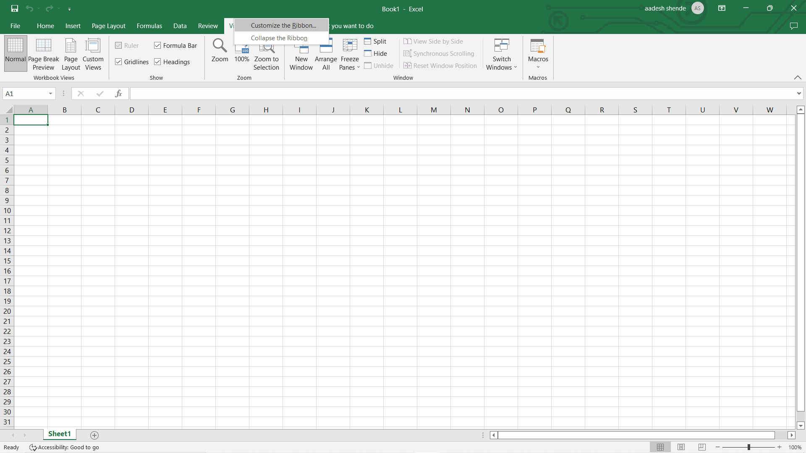

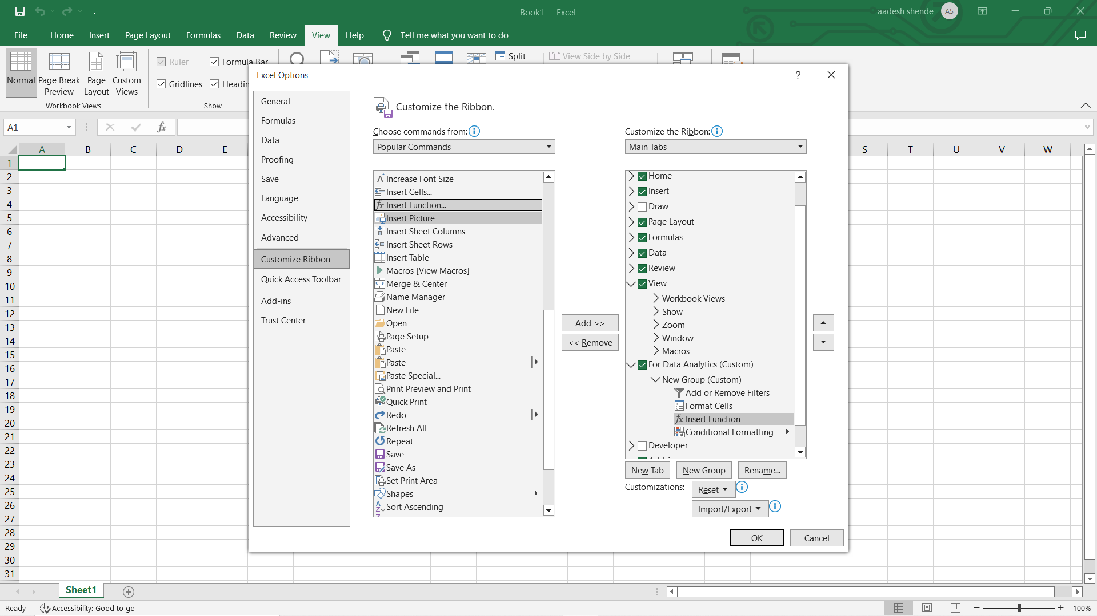

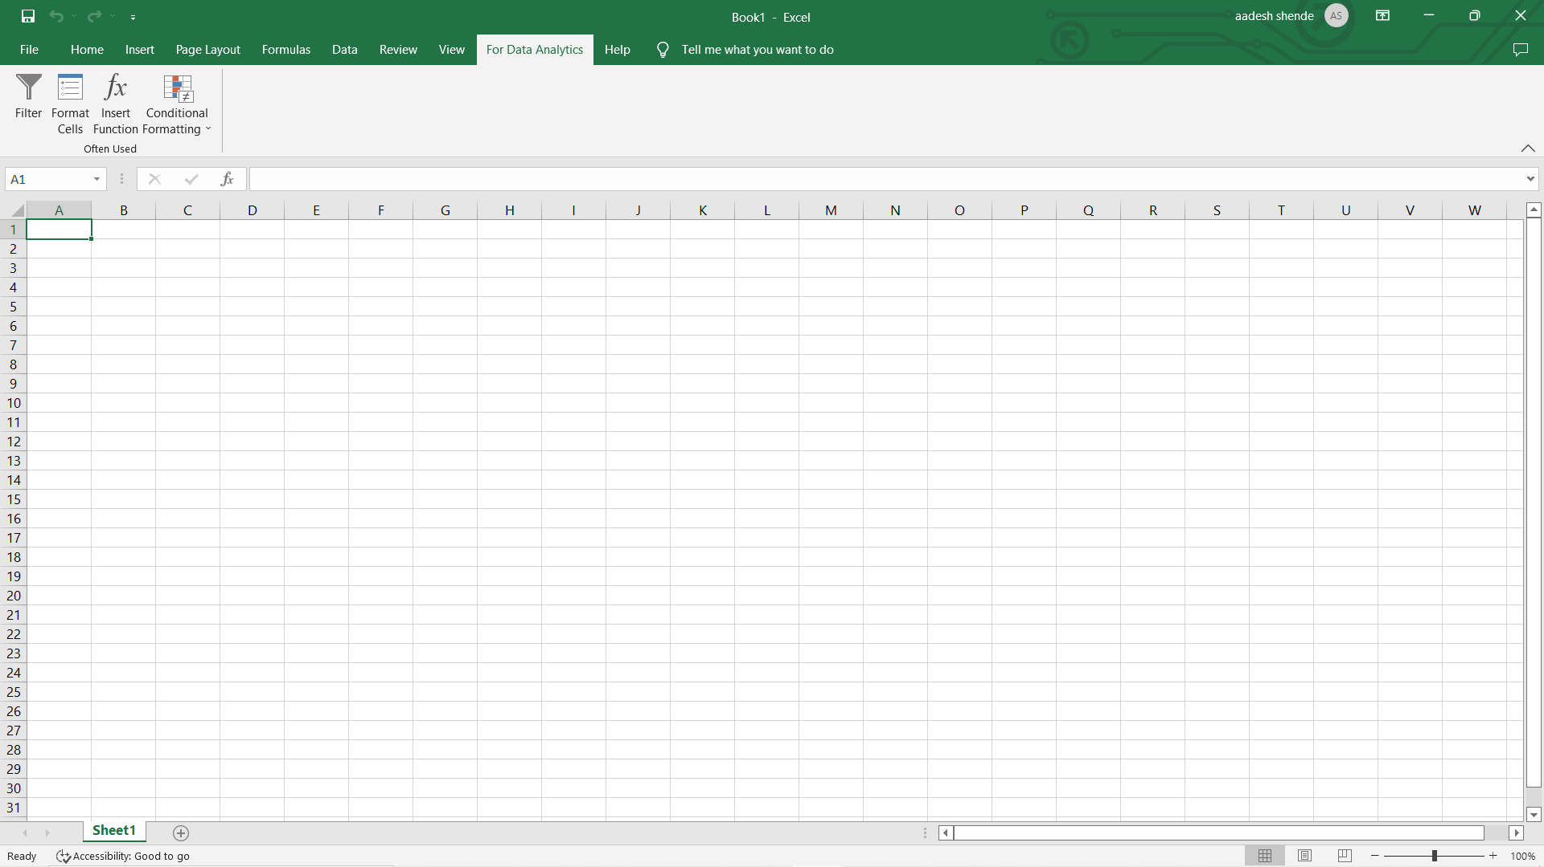

4. Make a list of different shortcut keys that are only connected to formatting with their functions.

Ans:

* Ctrl + Shift + ~ Apply general format.
* Ctrl + Shift + $ Apply currency format.
* Ctrl + Shift + % Apply percent format.
* Ctrl + Shift + ^ Apply scientific format.
* Ctrl + Shift + # Apply date format.
* Ctrl + Shift + @ Apply time format.
* Ctrl + Shift + ! Apply number format.
* Ctrl + 1 Open the Format Cells dialog box.
* Ctrl + B Apply or remove bold format.
* Ctrl + I Apply or remove italic format.
* Ctrl + U Apply or remove underline format.
* Ctrl + 5 Apply or remove strike format.

5. What distinguishes Excel from other analytical tools?

Ans: MS excel is a comprehensive tool that allows us to ANALYZE, SYNETHESIZE AND VISUALIZE information easily and in a meaningful way. There are 4 broad features in MS excel that makes it very useful for data analysis.

* MS Excel is a powerful spreadsheet that allows to do almost any level of data manipulation and analysis. Various excel functionalities like LOOKUP FUNCTIONS, PIVOT TABLES, SLICERS, etc that will help you to play with the data. Excel is also capable of handling extremely large data sets as well. Hence it is quite suited for the job of a data analyst.
* Excel has some great visualization tools that helps to present information in a graphical way. There are basic charts like LINE graph, Column chart, etc as well some advanced charting functions in excel that makes it highly apt as a visualization tool.
* It allows for creating an interactive user interface so that the user can make a choice of what they want to see. There are some advanced excel functions and functionalities like the OFFSET FUNCTION, list functionality etc. which will help you to make your models dynamic and interactive.
* Excel has in built programming functionalities with VBA macros that allows to play with extremely large and complicated volumes of data. There are some in-built STATISTICAL ADD-ins that will enable you to perform statistical regression based analysis as well on large data sets.
* 6. Create a table and add a custom header and footer to your table.

